Index.html:

<!DOCTYPE html>

<html lang="en">

    <head>

        <meta charset="UTF-8">

        <meta http-equiv="X-UA-Compatible" content="IE=edge">

        <meta name="viewport" content="width=device-width, initial-scale=1.0">

        <title>Spotify - Your favourite music is here</title>

        <link rel="stylesheet" href="style.css">

        </head>

<body>

    <nav>

        <ul>

            <li class="brand"><img src="musica.png" alt="Musia"> Musia</li>

            <li>Home</li>

            <li>About</li>

        </ul>

    </nav>

    <div class="container">

        <div class="songList">

            <h1>Best of NCS - Most Famous Music</h1>

            <div class="songItemContainer">

                <div class="songItem">

                    <img alt="1">

                    <span class="songName">Let me Love You</span>

                    <span class="songlistplay"><span class="timestamp">05:34 <i id="0" class="far songItemPlay fa-play-circle"></i> </span></span>

                </div>

                <div class="songItem">

                    <img alt="1">

                    <span class="songName">Let me Love You</span>

                    <span class="songlistplay"><span class="timestamp">05:34 <i id="1" class="far songItemPlay fa-play-circle"></i> </span></span>

                </div>

                <div class="songItem">

                    <img alt="1">

                    <span class="songName">Let me Love You</span>

                    <span class="songlistplay"><span class="timestamp">05:34 <i id="2" class="far songItemPlay fa-play-circle"></i> </span></span>

                </div>

                <div class="songItem">

                    <img alt="1">

                    <span class="songName">Let me Love You</span>

                    <span class="songlistplay"><span class="timestamp">05:34 <i id="3" class="far songItemPlay fa-play-circle"></i> </span></span>

                </div>

                <div class="songItem">

                    <img alt="1">

                    <span class="songName">Let me Love You</span>

                    <span class="songlistplay"><span class="timestamp">05:34 <i id="4" class="far songItemPlay fa-play-circle"></i> </span></span>

                </div>

                <div class="songItem">

                    <img alt="1">

                    <span class="songName">Let me Love You</span>

                    <span class="songlistplay"><span class="timestamp">05:34 <i id="5" class="far songItemPlay fa-play-circle"></i> </span></span>

                </div>

                <div class="songItem">

                    <img alt="1">

                    <span class="songName">Let me Love You</span>

                    <span class="songlistplay"><span class="timestamp">05:34 <i id="6" class="far songItemPlay fa-play-circle"></i> </span></span>

                </div>

                <div class="songItem">

                    <img alt="1">

                    <span class="songName">Let me Love You</span>

                    <span class="songlistplay"><span class="timestamp">05:34 <i id="7" class="far songItemPlay fa-play-circle"></i> </span></span>

                </div>

                <div class="songItem">

                    <img alt="1">

                    <span class="songName">Let me Love You</span>

                    <span class="songlistplay"><span class="timestamp">05:34 <i id="8" class="far songItemPlay fa-play-circle"></i> </span></span>

                </div>

                <div class="songItem">

                    <img alt="1">

                    <span class="songName">Let me Love You</span>

                    <span class="songlistplay"><span class="timestamp">05:34 <i id="9" class="far songItemPlay fa-play-circle"></i> </span></span>

                </div>

            </div>

        </div>

        <div class="songBanner"></div>

    </div>

    <div class="bottom">

        <input type="range" name="range" id="myProgressBar" min="0" value="0" max="100">

        <div class="icons">

            <!-- fontawesome icons -->

            <i class="fas fa-3x fa-step-backward" id="previous"></i>

            <i class="far fa-3x fa-play-circle" id="masterPlay"></i>

            <i class="fas fa-3x fa-step-forward" id="next"></i>

        </div>

        <div class="songInfo">

            <img src="playing.gif" width="42px" alt="" id="gif"> <span id="masterSongName">Warriyo - Mortals [NCS Release]</span>

        </div>

    </div>

    <script src="script.js"></script>

    <script src="https://kit.fontawesome.com/26504e4a1f.js" crossorigin="anonymous"></script>

</body>

</html>

Style.CSS:

@import url('https://fonts.googleapis.com/css2?family=Ubuntu&display=swap');

@import url('https://fonts.googleapis.com/css2?family=Varela+Round&display=swap');

body{

    background-color: antiquewhite;

}

\*{

    margin: 0;

    padding: 0;

}

nav{

    font-family: 'Ubuntu', sans-serif;

}

nav ul{

    display: flex;

    align-items: center;

    list-style-type: none;

    height: 65px;

    background-color: black;

    color: white;

}

nav ul li{

    padding: 0 12px;

}

.brand img{

    width: 44px;

    padding: 0 8px;

}

.brand {

    display: flex;

    align-items: center;

    font-weight: bolder;

    font-size: 1.3rem;

}

.container{

    min-height: 72vh;

    background-color: black;

    color: white;

   font-family: 'Varela Round', sans-serif;

   display: flex;

   margin: 23px auto;

   width: 70%;

   border-radius: 12px;

   padding: 34px;

   background-image: url('finallybackgroundimage2.jpg');

}

.bottom{

    position: sticky;

    bottom: 0;

    height: 130px;

    background-color: black;

    color: white;

    display: flex;

    justify-content: center;

    align-items: center;

    flex-direction: column;

}

.icons{

    margin-top: 14px;

}

.icons i{

    cursor: pointer;

}

#myProgressBar{

    width: 80vw;

    cursor: pointer;

}

.songItemContainer{

    margin-top: 74px;

}

.songItem{

    height: 50px;

    display: flex;

    background-color: white;

    color: black;

    margin: 12px 0;

    justify-content: space-between;

    align-items: center;

    border-radius: 34px;

}

.songItem img{

    width: 43px;

    margin: 0 23px;

    border-radius: 34px;

}

.timestamp{

    margin: 0 23px;

}

.timestamp i{

    cursor: pointer;

}

.songInfo{

    position: absolute;

    left: 10vw;

    font-family: 'Varela Round', sans-serif;

}

.songInfo img{

    opacity: 0;

    transition: opacity 0.4s ease-in;

}

@media only screen and (max-width: 1100px) {

    body {

      background-color: red;

    }

  }

Script.js:

console.log("Welcome Musica");

// Initialize the Variables

let songIndex = 0;

let audioElement = new Audio('songs/1.mp3');

let masterPlay = document.getElementById('masterPlay');

let myProgressBar = document.getElementById('myProgressBar');

let gif = document.getElementById('gif');

let masterSongName = document.getElementById('masterSongName');

let songItems = Array.from(document.getElementsByClassName('songItem'));

let songs = [

    {songName: "Warriyo - Mortals [NCS Release]", filePath: "songs/1.mp3", coverPath: "covers/1.jpg"},

    {songName: "Cielo - Huma-Huma", filePath: "songs/2.mp3", coverPath: "covers/2.jpg"},

    {songName: "DEAF KEV - Invincible [NCS Release]-320k", filePath: "songs/3.mp3", coverPath: "covers/3.jpg"},

    {songName: "Different Heaven & EH!DE - My Heart [NCS Release]", filePath: "songs/4.mp3", coverPath: "covers/4.jpg"},

    {songName: "Janji-Heroes-Tonight-feat-Johnning-NCS-Release", filePath: "songs/5.mp3", coverPath: "covers/5.jpg"},

    {songName: "Diffrent Paths - Warrior", filePath: "songs/2.mp3", coverPath: "covers/6.jpg"},

    {songName: "Justein Beiber - I Do the same", filePath: "songs/2.mp3", coverPath: "covers/7.jpg"},

    {songName: "Nirvana covering David Bowie - The Man who Sold the World", filePath: "songs/2.mp3", coverPath: "covers/8.jpg"},

    {songName: "Kaizer - Astral World", filePath: "songs/2.mp3", coverPath: "covers/9.jpg"},

    {songName: "Anezer - Feels to Fly", filePath: "songs/4.mp3", coverPath: "covers/10.jpg"},

]

songItems.forEach((element, i)=>{

    element.getElementsByTagName("img")[0].src = songs[i].coverPath;

    element.getElementsByClassName("songName")[0].innerText = songs[i].songName;

})

// Handle play/pause click

masterPlay.addEventListener('click', ()=>{

    if(audioElement.paused || audioElement.currentTime<=0){

        audioElement.play();

        masterPlay.classList.remove('fa-play-circle');

        masterPlay.classList.add('fa-pause-circle');

        gif.style.opacity = 1;

    }

    else{

        audioElement.pause();

        masterPlay.classList.remove('fa-pause-circle');

        masterPlay.classList.add('fa-play-circle');

        gif.style.opacity = 0;

    }

})

// Listen to Events

audioElement.addEventListener('timeupdate', ()=>{

    // Update Seekbar

    progress = parseInt((audioElement.currentTime/audioElement.duration)\* 100);

    myProgressBar.value = progress;

})

myProgressBar.addEventListener('change', ()=>{

    audioElement.currentTime = myProgressBar.value \* audioElement.duration/100;

})

const makeAllPlays = ()=>{

    Array.from(document.getElementsByClassName('songItemPlay')).forEach((element)=>{

        element.classList.remove('fa-pause-circle');

        element.classList.add('fa-play-circle');

    })

}

Array.from(document.getElementsByClassName('songItemPlay')).forEach((element)=>{

    element.addEventListener('click', (e)=>{

        makeAllPlays();

        songIndex = parseInt(e.target.id);

        e.target.classList.remove('fa-play-circle');

        e.target.classList.add('fa-pause-circle');

        audioElement.src = `songs/${songIndex+1}.mp3`;

        masterSongName.innerText = songs[songIndex].songName;

        audioElement.currentTime = 0;

        audioElement.play();

        gif.style.opacity = 1;

        masterPlay.classList.remove('fa-play-circle');

        masterPlay.classList.add('fa-pause-circle');

    })

})

document.getElementById('next').addEventListener('click', ()=>{

    if(songIndex>=9){

        songIndex = 0

    }

    else{

        songIndex += 1;

    }

    audioElement.src = `songs/${songIndex+1}.mp3`;

    masterSongName.innerText = songs[songIndex].songName;

    audioElement.currentTime = 0;

    audioElement.play();

    masterPlay.classList.remove('fa-play-circle');

    masterPlay.classList.add('fa-pause-circle');

})

document.getElementById('previous').addEventListener('click', ()=>{

    if(songIndex<=0){

        songIndex = 0

    }

    else{

        songIndex -= 1;

    }

    audioElement.src = `songs/${songIndex+1}.mp3`;

    masterSongName.innerText = songs[songIndex].songName;

    audioElement.currentTime = 0;

    audioElement.play();

    masterPlay.classList.remove('fa-play-circle');

    masterPlay.classList.add('fa-pause-circle');

})

OUTPUT:  


The logo is copied here with the help of CSS and HTML and we have put it inside the navigation bar including home and about page.



The play/pause button help us to stop or play the music and the progress bar tells us how long is it before the song ends and the forward button plays the next song and the backward button plays the song before the current song.

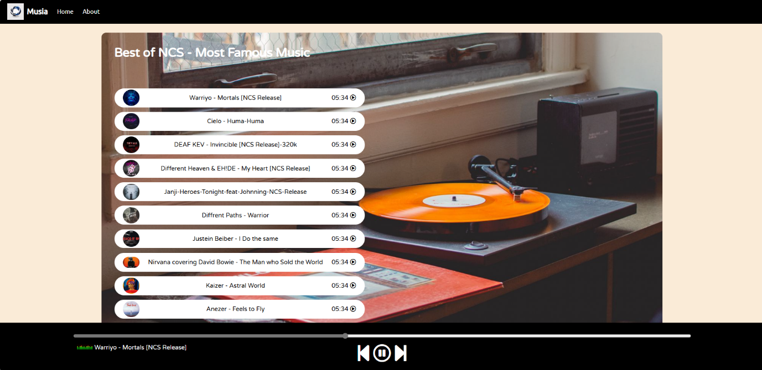

AND this is the final look of our website, All the buttons are fully functional and song plays when you click on any of the song inside the white container.